**Master Microcontroller with Wi-Fi**

(ESP8266-NODE MCU)

|**Wired Sensors**

(Air Parameters, Light Intensity, UV Intensity)

RFM Radio (Master) Module

**Router**

**BMS + Battery** (18650)



RFM96W

2.4 GHz Wi-FI

**Access Point**

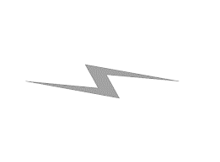

JSON Format

HTTP Protocol

GSM Comunication



LORA Technology

433 Mhz



Cloud

HTML, CSS, Django based Platform

**WSN Nodes**

**Battery**

(18650)

**RFM Radio** (Slave) **Module**

**Node Microcontroller**

(ATMega 328P-AU)

|**Sensors**

(Moisture, Temperature, EC)



**Battery**

(18650)

**RFM Radio** (Slave) **Module**

**Node Microcontroller**

(ATMega 328P-AU)

|**Sensors**

(Moisture, Temperature, EC)



**Battery**

(18650)

**RFM Radio** (Slave) **Module**

**Node Microcontroller**

(ATMega 328P-AU)

|**Sensors**

(Moisture, Temperature, EC)



RFM96W



**User Interface**

Tables, Control Buttons, Charts, Levels